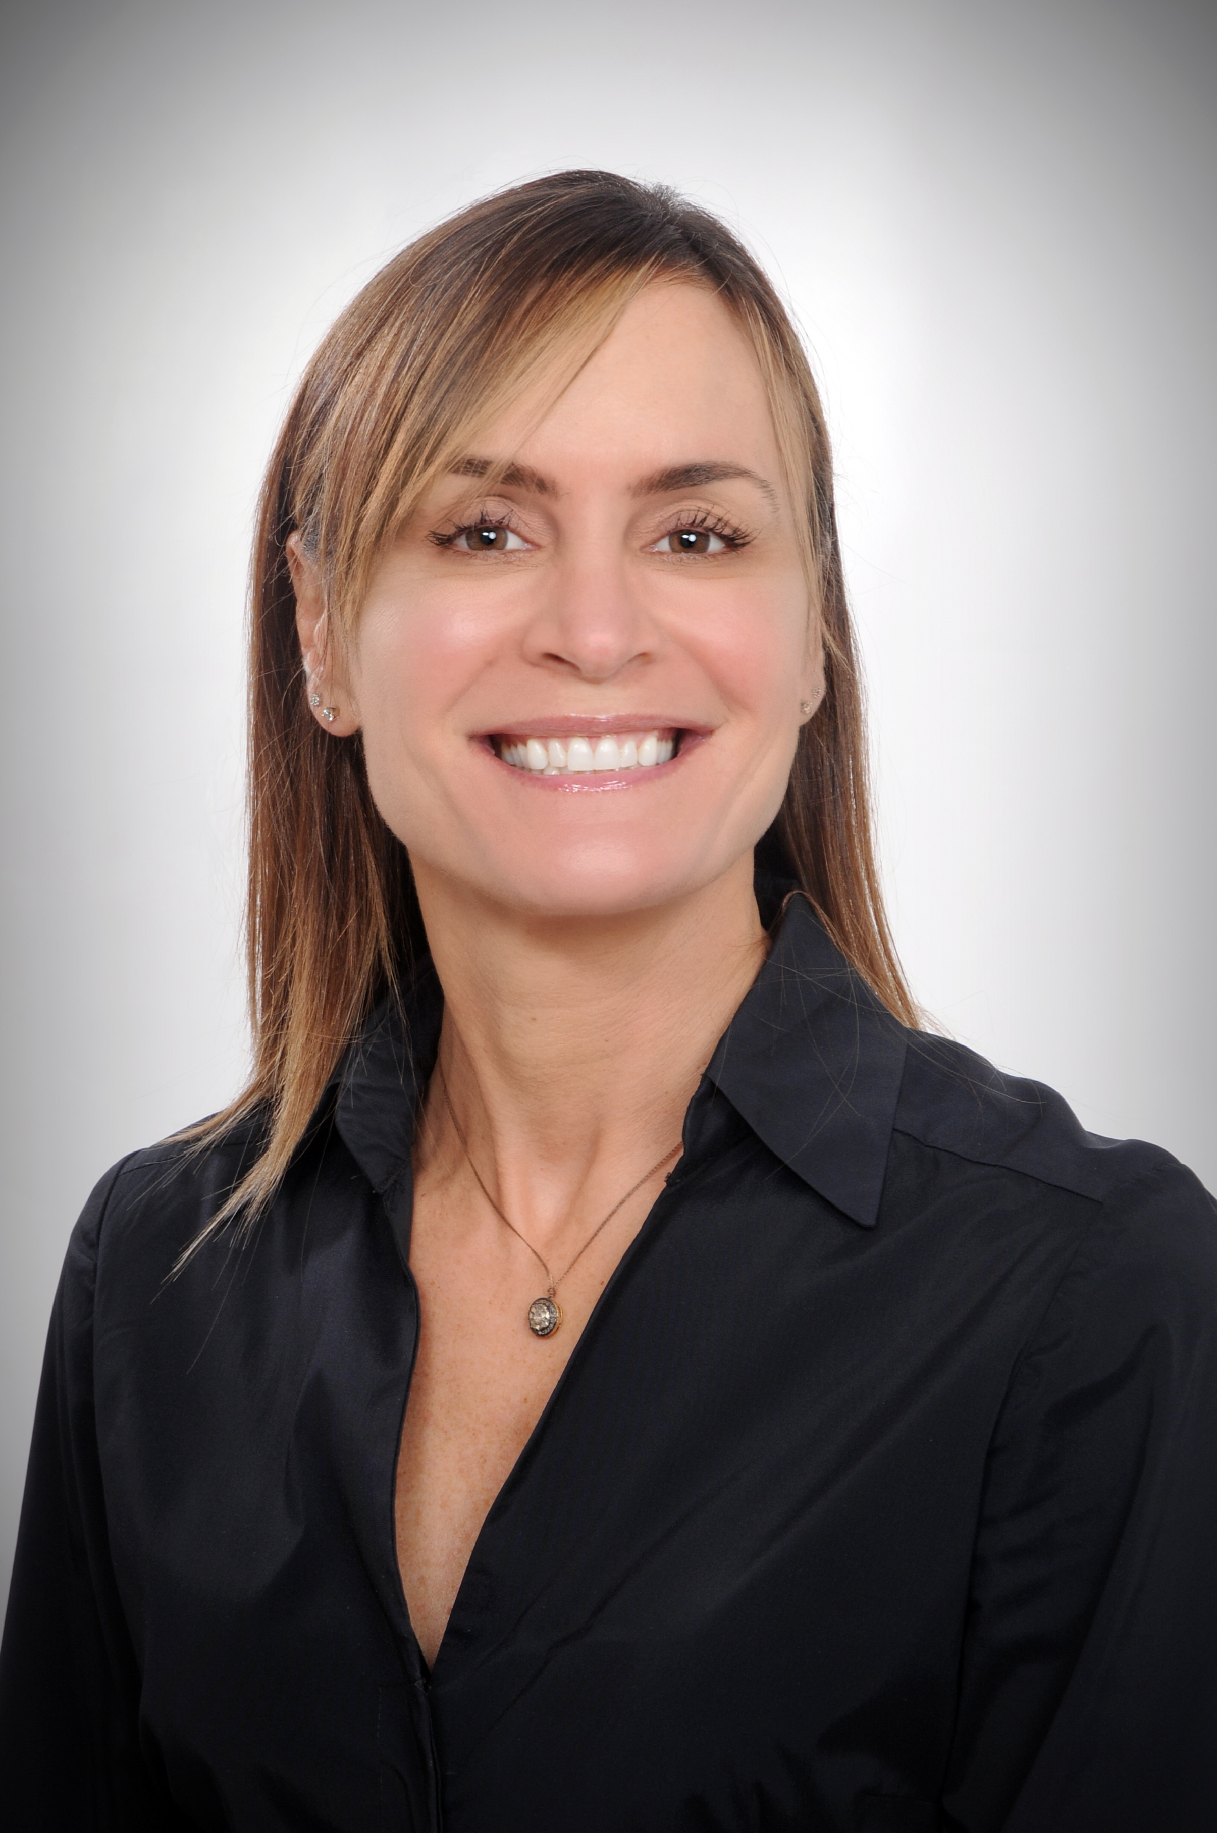

Wendy Hosterman is a Senior Marketing Consultant for JDA.media.

Over the course of Wendy’s nearly 25-years in media, she’s worked successfully in multiple categories from automotive to retail to healthcare and more. She possesses a unique depth of knowledge as a seller, manager, and executive at privately-owned media companies as well as Fortune 500 firms.

“I have always been a top performer winning multiple President's Cups, Pinnacle Awards, and various client honors,” she says proudly. But her real professional passion is connecting with local businesses to help them grow and cut through the clutter.
During her nearly 11-year tenure with Cox Media Group (CMG) in Tulsa, Wendy specialized in leveraging television, radio, and digital platforms for her clients. In her years with the company, she was recognized four consecutive years with the prestigious CMG President’s Circle Award, and Top Digital Performer (in Oklahoma) for five consecutive years.

Prior to working with Cox, Wendy led local initiatives at Newport Television in Tulsa and was a Local Sales Manager. She oversaw a team of six, achieved record revenue goals, launched and managed a successful lifestyle/sponsorship program that generated over $300,000 in its inaugural year.

“I've spent my career putting together the right solutions and the right messaging for customers. I am transparent, and pride myself on being a great listener,” she says. “I can connect with local business owners because I've been working with them and creating solutions that grow their companies for nearly 25 years.” Her methodology includes maintaining constant contact with customers. “It’s critical, and part of our responsibility is to manage expectations and make changes when needed.”

Wendy is a passionate sports fan, a proud University of Kansas graduate who worked in the athletic department. Nowadays, her outside-of-work passion is centered on exercise, which includes running, barre, yoga, and spin.

She and her husband Greg have been married for 24 years and are the proud parents of two amazing sons, Noel and Shane, and a pair of rescue dogs.

BIOGRAPHY

Florida Office:
7711 Holiday Drive
Sarasota, FL 34231

Dallas Office:
7221 Twin Tree Ln
Dallas, TX 75214

