About David Melville

David Melville started as a JDA.media Senior Marketing Consultant in 2004.

During his years at JDA.media he’s produced results for businesses in over 50 U.S. television markets all over the U.S.

He has served as Executive Producer for two JDA.media national health care conferences focused on promoting effective marketing practices for healthcare providers.

David brings nearly 30-years of broadcast experience to the team at JDA.media, ranging from production to sales as well as advertising agency management. His vast commercial background includes working as a successful producer, director, and editor. David received training at the prestigious SONY Institute in Hollywood, as well as the International Film and Television Workshop in Maine.

After a successful career in production, he moved into television sales where he utilized the JDA.media UpgradeSelling system to increase results for his local clients. As a salesperson, he was consistently the top biller.

In 1999, David founded Dirigo Marketing, a New England ad agency specializing in broadcast and cable TV advertising. He works as a marketing strategist and a media buyer for businesses that want to stand apart from their competition and increase the impact of their advertising. His long list of clients includes car dealers, retailers, restaurants, furniture stores, and business-to-business companies.

David grew up in coastal Kingston, Massachusetts and comes from a long line of writers, which includes Herman Melville, author of the American literary classic Moby-Dick. He graduated with honors from the University of Maine with a degree in Communications and Public Relations.

Today, he lives in Portland, Maine with his wife and their six sons where he enjoys baseball, coaching, boating, and singing.

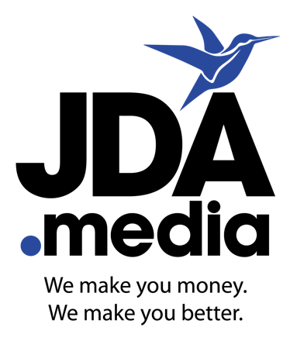

BIOGRAPHY

7711 Holiday Drive
Sarasota, FL 34231
941.926.7355

